**SEE U**

**Software Revision and Control**



Hang Xie 1025910

Jiasheng Yu 1025957

Rui Chen 1025567

Jinhang Wu 1025891

**Version: (1.0)** **Date: (05/03/2020)**

**Table Content**

**Git Procedures 3**

**Issue 1 5**

**Solution 6**

**Issue 2 7**

**Solution 7**

**Issue 3 8**

**Conclusion 8**

# Git Procedures

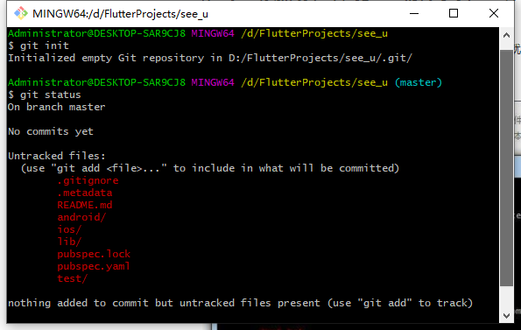



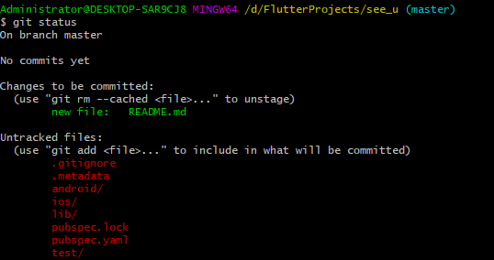

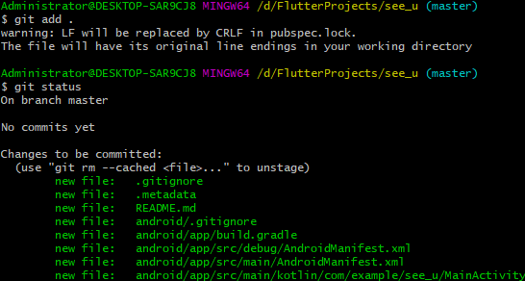

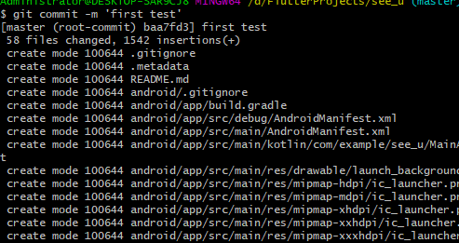



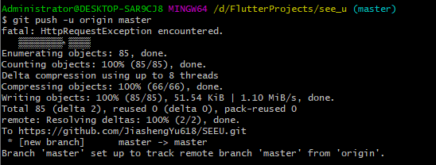

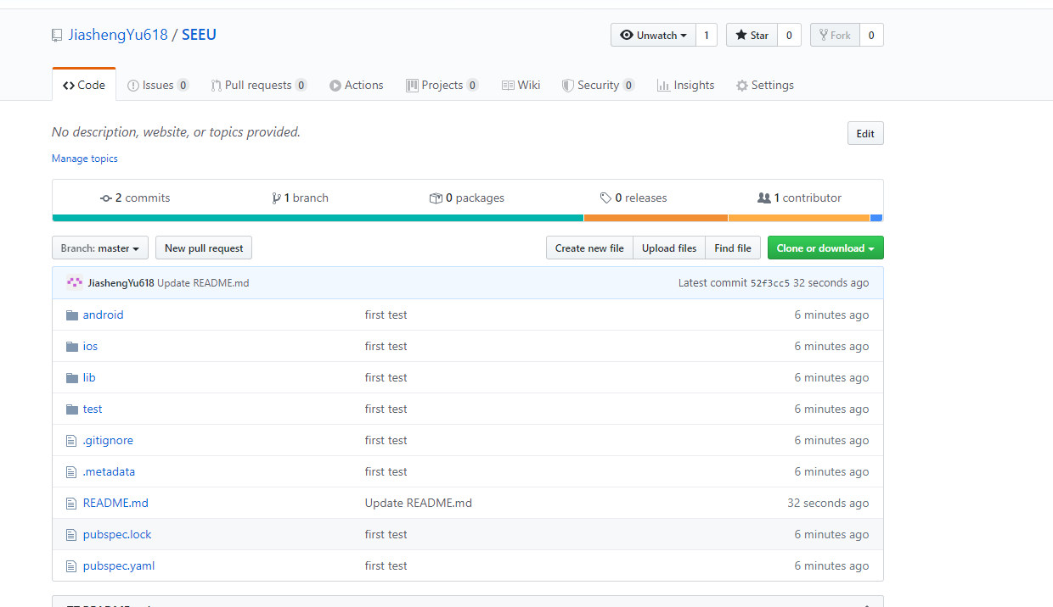

# Bugs and issues

By implementing the project, we need to install the environment of Flutter and use Android Studio or Visual Studio Code. However, there are lots of issues showing up.

## Issue 1

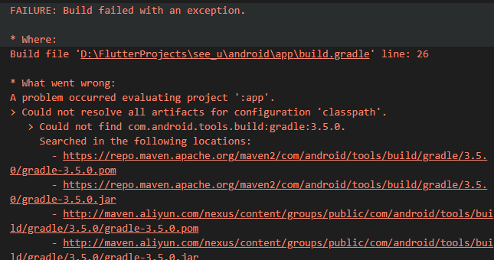

### Solution

1. Add Ali Cloud Mirror under flutter.gradle

maven{ url 'https://maven.aliyun.com/repository/google' }

maven{ url 'https://maven.aliyun.com/repository/jcenter' }

maven{url 'http://maven.aliyun.com/nexus/content/groups/public'}

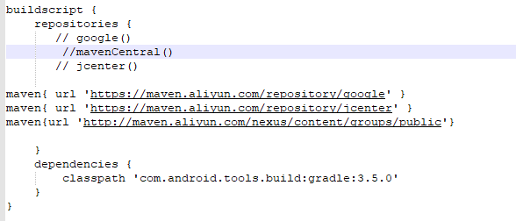

This method cannot solve the problem.

1. Use VPN

It still cannot solve the problem.

## Issue 2

After we use the methods above, it even shows more issues.

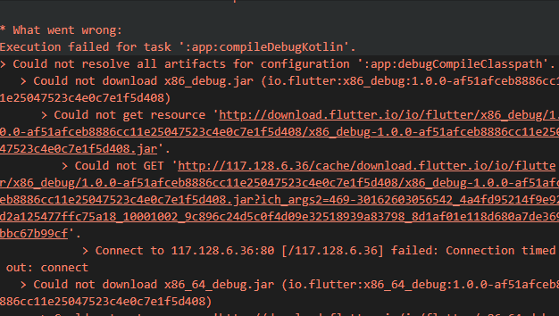

### Solution

I remove the notation of mavenCentral()

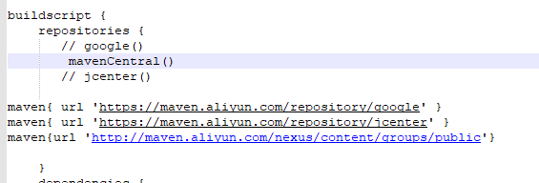

It doesn’t work, either.

## Issue 3

Then, it shows different issues again……

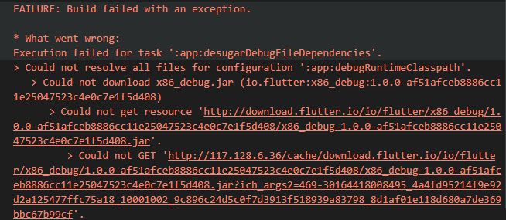

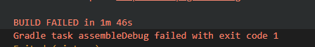

Still… it cannot solve the issue

# Conclusion

Each member of our group cannot implement the program under the environment of Flutter. Thus, we will change the IDE and programming language to redevelop the project. Finally, we end up with switching to Vue.js as our front end and Django as our back end.